[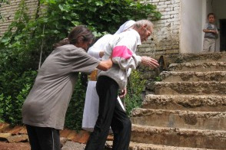](http://blog.caritas-international.de/wp-content/uploads/2013/05/albanien4_1.jpg)